M.A. Jones Elementary School

Date: October 9, 2025

Time: 4:26pm-5:52pm

Location: Zoom & [YouTube](https://www.youtube.com/watch?v=zuUGfusRSBY)

1. Call to Order: 4:26pm
2. Roll Call

|  |  |  |
| --- | --- | --- |
| **Role** | **Name** | **Present or Absent** |
| Principal | Teruko Dobashi | Present |
| Parent/Guardian | Ayana Dunston | Present |
| Parent/Guardian | Meghan Plumb | Absent |
| Parent/Guardian | Shyretha Sheats | Present |
| Instructional Staff | Janni Buggs | Present |
| Instructional Staff | Cole Pryor | Present |
| Instructional Staff | Latoya Bostic | Present |
| Community Member | Melissa Waller | Absent |
| Community Member | Raquel Hudson | Present |
| Swing Seat | Krista Verdelotti | Present |

Quorum is met.

1. Action Items
   1. Approval for Agenda
      1. MOTION: Verdelotti
      2. SECOND: Bostic
      3. RESULTS: Motion passed
   2. Approval of [Previous Minutes](https://www.atlantapublicschools.us/cms/lib/GA01000924/Centricity/Domain/10662/Final%20MAJ%20Meeting%20Minutes%20August%2019%202025.pdf) of September 11, 2025
      1. MOTION: Hudson
      2. SECOND: Verdelotti
      3. RESULT: Motion passed unanimously
2. Discussion Items
   1. School Strategic Plan
      1. Key Performance Indicator [(KPI) Review](https://drive.google.com/drive/folders/1X8V_go4jCMkDK1-eKo0fxRrdT5TGZewj) for 2025-2030 (minute marker 17:10)
         1. GOTeam discussed low ranked items and how to achieve Johnson’s goals by 2030.
            1. Our Strength is Our Team > Staff Engagement > % of engaged staff is 33.3% (2025)
      2. SMART Goals
         1. Mission and Vision
            1. 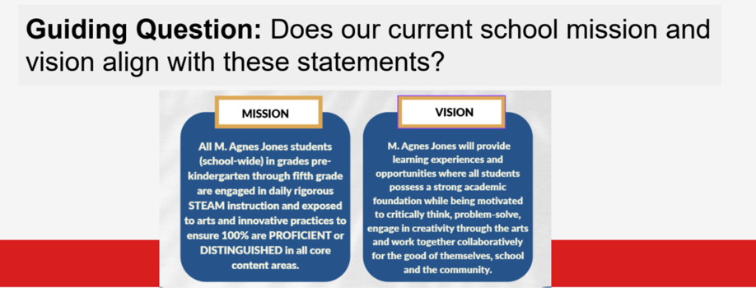
            2. GOTeam came up with

Mission & Vision:

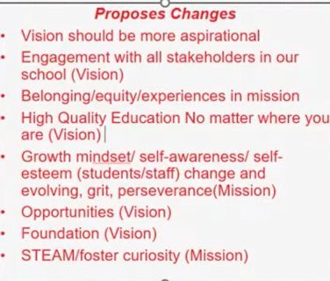

* + - * 1. Dobashi is going to devise an enhanced Mission & Vision (by November meeting) for GOTeam to vote. Then take the top ranked items back to MAJ Team members for final vote.
      1. Strategic Plan & Priorities

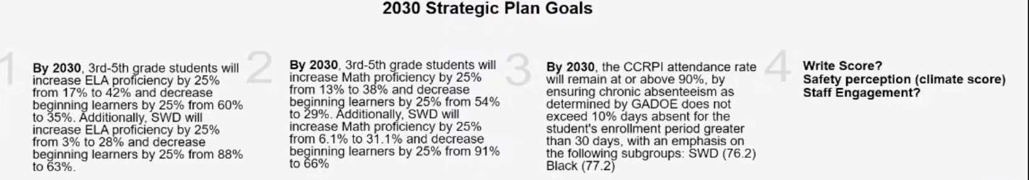

* + - * 1. Our Strength is Our Team > Staff Engagement > % of engaged staff is 33.3% (2025)
  1. School Updates:
     1. STEAM Recertification:
        1. District Support Specialists will collaborate with school leadership to identify targeted next steps aligned to Spring STEAM Walk feedback. Focus areas will include strengthening integration across content areas, increasing student voice and choice in STEAM activities, and ensuring alignment to the district’s STEAM Framework and instructional look-fors.
        2. State said its going to be very hard to be recertified when you’re on the state turn around list.
           1. MAJ is focused on Math & ELA
        3. Verdelotti: Is this the first time MAJ has been on the State Turn Around List?
           1. Dobashi: Yes, first time ever.
     2. Q2 Short-Term Action Plans
        1. The Leadership Team collaboratively developed short-term action plans for Quarter 2 (October–December) to make goals and action steps more focused, measurable, and manageable. These plans are designed to ensure consistent progress monitoring and alignment to our overall school improvement priorities.
           1. Publishing Party, Tracking Small Groups
     3. 2025 Family Engagement Award from Families First
     4. Appreciation for Mr. Smith & Ms. Odums for our clean building.
     5. Profession Learning
        1. Teachers will engage in two days of professional learning on Monday, October 13 and Tuesday, October 14. The schoolwide focus will include:
           1. Strengthening Explicit Instruction practices
           2. Building leadership capacity through the Ladder of Inference
           3. Engaging in self-assessment and reflection
           4. Analyzing writing rubrics
           5. Submitting Quarter 1 SWARM reports

Any student who has missed more than 3-5 days of school to Burney Mitchell (school social worker).

* + 1. APS Forward 2040:
       1. Verdelotti shared tonight is recommendations with first read to board in November; with vote in December.

1. Announcements
   1. Fall Break 10/13 /2025 through 10/17/2025
   2. Write Score 10/20/2025 through 10/24/2025
   3. Literacy Week 10/27/2025 through 10/31/2025
      1. Literacy Night 10/29/2025
   4. Fall Festival 11/1/2025
   5. NO SCHOOL 11/4/2025
   6. Bostic Birthday 11/4
   7. Dobashi Birthday 11/11
2. Adjournment
   1. MOTIONED: Pryor
   2. SECONDED: Bostic
   3. RESULT: Motion passed

ADJOURNMENT at 5:52PM

--------------------------------------------------------------------------------------------------------------------------

Minutes Taken By: Krista Verdelotti in collaboration with ZOOM AI

Position: Secretary

Date Approved: